Mantid Geometry Primitives

Mantid currently supports the following geometry primitives fully:

- Sphere
- Infinite Cylinder
- Infinite Plane

From these primitives other shapes may be constructed using the algebra

( ) Brackets to group shapes eg ( 22 24 )
: Union eg 22 : 24
No operator means intersection eg 22 24
# Complement eg #( 22 24 )
- Complement (for a single primitive) eg -22

Thus, for a single primitive both # and - can be used to express the complement, where the latter operator may be computationally more efficient. Note, when defining shapes in an instrument definition file (IDF) only the # complement operator is allowed.

In addition to defining primitives in an IDF the following shapes (within an IDF) can be directly specified:

- Cuboid
- Cylinder (i.e. with finite height)
- Hexahedron (as defined below) (almost done.....)

Mantid also has partially support for:

- Double Infinite Cone (believed to be)
- Torus
- Generic Quadratic surface

Instrument definition file XML tag descriptions

Sphere:

<sphere id="Bertie">
<centre x="4.1" y="2.1" z="8.1" />
<radius val="3.2" />
</sphere>

Cylinder:

Finite:
<cylinder id="Bertie">
<centre-of-bottom-base r="0.0" t="0.0" p="0.0" />
<axis x="0.0" y="0.2" z="0" />
<radius val="1" />
<height val="10.2" />
</cylinder>
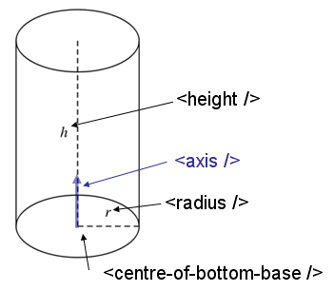

Infinite:
<infinite-cylinder id="Bertie" >
<centre x="0.0" y="0.2" z="0" />
<axis x="0.0" y="0.2" z="0" />
<radius val="1" />
</infinite-cylinder>

Cone:

Finite:
<cone id="Bertie" >
<tip-point x="0.0" y="0.2" z="0" />
<axis x="0.0" y="0.2" z="0" />
<angle val="30.1" />
<height vale="10.2" />
</cone>

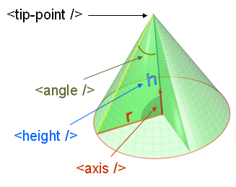

Infinite:
<infinite-code id="Bertie" >
<tip-point x="0.0" y="0.2" z="0" />
<axis x="0.0" y="0.2" z="0" />
<angle val="30.1" />
</infinite-code>

Infinite plane:

<infinite-plane id="10">
<point-in-plane x="0.0" y="0.2" z="0" />
<normal-to-plane x="0.0" y="0.2" z="0" />
</infinite-plane>

Cuboid:

<cuboid id="Bertie">
<left-front-bottom-point x="0.0" y="0.2" z="0" />
<left-front-top-point x="0.0" y="0.2" z="0" />
<left-back-bottom-point x="0.0" y="0.2" z="0" />
<right-front-bottom-point x="0.0" y="0.2" z="0" />
</cuboid>

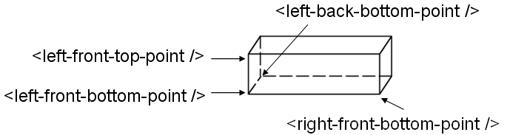

Work in progres

Cone:

Finite:
<cone id="Bertie" >
<tip-point x="0.0" y="0.2" z="0" />
<axis x="0.0" y="0.2" z="0" />
<angle val="30.1" />
<height vale="10.2" />
</cone>

Infinite:
<infinite-code id="Bertie" >
<tip-point x="0.0" y="0.2" z="0" />
<axis x="0.0" y="0.2" z="0" />
<angle val="30.1" />
</infinite-code>

Generic Quadratic Surface:

<quadratic-surface id="Bertie">
<A val="2.1" />
<B val="1.1" />
<C val="1.1" />
<D val="1.1" />
<E val="1.1" />
<F val="1.1" />
<G val="1.1" />
<H val="1.1" />
<J val="1.1" />
<K val="1.1" />
</ quadratic-surface>

A surface defined by the equation Ax^2+By^2+Cz^2+Dxy+Exz+Fyz+Gx+Hy+Jz+K=0 may for instance define the surface of a sphere or ellipsoid or an infinite plane.

Torus:

<torus id="Bertie" >
<centre x="0.0" y="0.2" z="0" />
<axis x="0.0" y="0.2" z="0" />
<radius-from-centre-to-tube val="5" />
<radius-tube val="1" />
</torus>
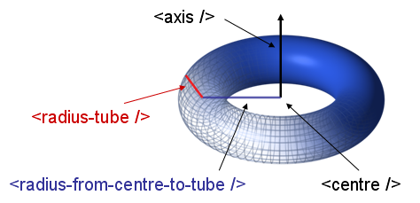

Alternative infinite plane description

To describe an infinite plane using Ax+By+Cz-D=0

<infinite-plane id="Bertie" A="1" B="1" C="1" D="1" />

Finite plane:

<plane id="bob" >
<front-left-point x="0.0" y="0.2" z="0" />
<back-left-point x="0.0" y="0.2" z="0" />
<front-right-point x="0.0" y="0.2" z="0" />
</plane>

Hexahedron:

<hexahedron id="Bertie">
<bottom-vertices>
<point x="0.0" y="0.2" z="0" />
<point x="0.0" y="0.2" z="0" />
<point x="0.0" y="0.2" z="0" />
<point x="0.0" y="0.2" z="0" />
</bottom-vertices>
<top-vertices>
<point x="0.0" y="0.2" z="0" />
<point x="0.0" y="0.2" z="0" />
<point x="0.0" y="0.2" z="0" />
<point x="0.0" y="0.2" z="0" />
</ top-vertices>
</hexahedron>

Short description of all shapes (needs a bit of editing)

Sphere:
Sphere(Centre(Point),Radius);
Centre(Point) : Centre of the Sphere
Radius : Radius of the Sphere
Cylinder:
Finite: Cylinder(Centre(Point),Normal(Vector),Radius,Height)
Centre(Point) : Centre of the Cylinder base
Normal(Vector) : Normal of the Cylinder Axis
Radius : Radius of the Cylinder
Height : Height of the Cylinder from base
Infinite: Cylinder(Centre(Point),Radius)
Centre(Point) : Cylinder Axis passes through the Centre Point
Normal(Vector) : Normal of the Cylinder Axis
Radius : Radius of the Cylinder
Cone:
Finite: Cone(Centre(Point),Normal(Vector),Angle,Height)
Center(Point) : Tip point of the Cone
Normal(Vector) : Normal of the Cone Axis
Angle : Angle of the cone side with cone axis
Height : Height of the cone
Infinite: Cone(Centre(Point), Normal(Vector),Angle)
Centre(Point) : Tip point of the Cone
Normal(Vector) : Normal of the Cone Axis
Angle : Angle of the cone side with cone axis
Plane:
Finite: Plane(Start(Point),End(Point))
Start(Point) : bottom left point of the plane
End(Point) : top right point of the plane
Infinite: Plane(A,B,C,D)
A,B,C,D in the equation Ax+By+Cz-D=0
Torus:
Finite: Torus(Centre(Point),Normal(Vector),CRadius,TRadius)
Centre(Point): Centre of the Torus
Normal(Vector) : Normal of the torus axis
CRadius : Radius from centre of Torus to the centre of the tube
TRadius : Radius of the Tube
Generic Quadratic Surface:
Infinite: Generic(A,B,C,D,E,F,G,H,J,K)
Ax^2+By^2+Cz^2+Dxy+Exz+Fyz+Gx+Hy+Jz+K=0

